Communication & Electronics Department

**Network (2), CCE 463**

**Fourth Year**

**Computers and Control Eng. (CCE) Program**

**Regulation (2019)**

**Second Semester, 2023/2024**

**Experiment (3): RIPv2 Routing and Configuration**

**Student Name** : Abdelrahman Mahmoud Abdelrahman Mahmoud

**Student Code** : 125200238

**Section Number** : 2

**Student Number in the registration statement** :32

Dr/ Mohamed Abdelhamid

Eng/Menna Samy

Program Setup (Packet Tracer)

**Simulation Results**

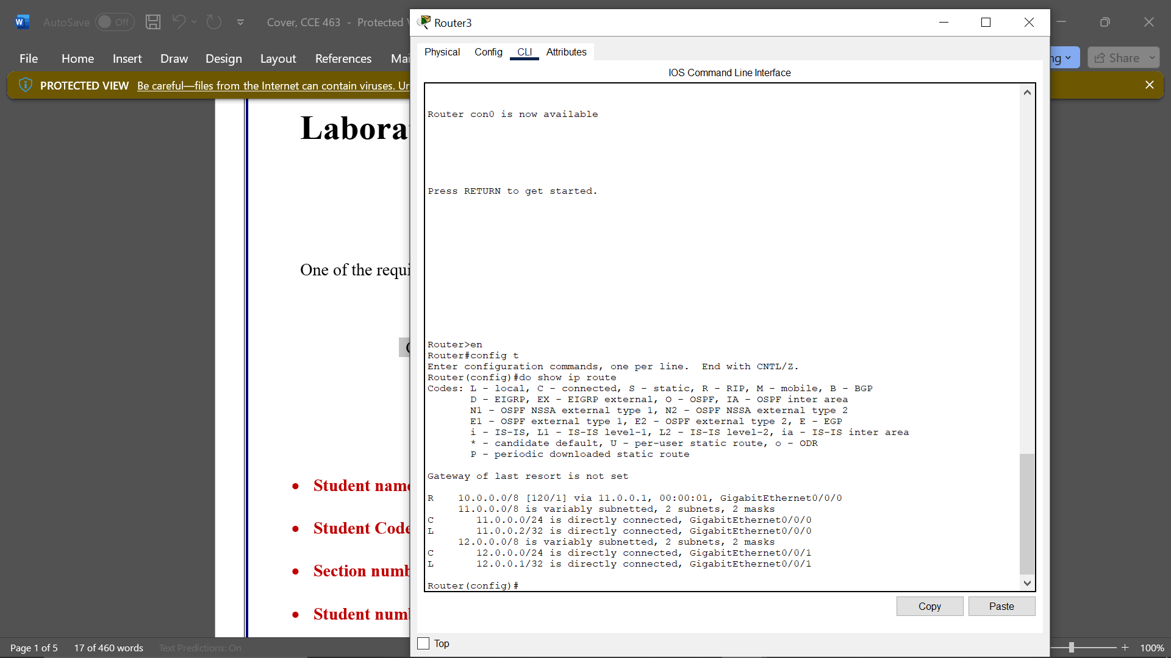

Program Setup (eNSP)

**Simulation Results**



